23CSE202 DATABASE MANAGEMENT SYSTEMS
S3 B.Tech CSE
Department of Computer Science and Engineering
Amrita School of Computing, Amritapuri Campus

PROJECT REPORT

Group No :
Team Members :
Roll No | Student Name
AM.SC.U4CSE25204 | ANJANA R
AM.SC.U4CSE25219 | GOWRI MENON
AM.SC.U4CSE25230 | LEKSHMI NANDANA PRAVEEN
AM.SC.U4CSE25232 | MEENAKSHI NM

Project Title : BLOOD CONNECT

- CONTENTS
Sl. No | Chapter | Page No
1 | Abstract
2 | Introduction
3 | Requirements (Functional & Non-functional)
4 | UI Design
5 | Database Design
6 | Database Selection & Justification
7 | Implementation
8 | Testing & Validation
9 | Results & Screenshots
10 | Challenges faced & solutions
11 | Conclusion & future enhancements
 | References

1. ABSTRACT
BloodConnect is a Blood Donation Management System developed to manage information about blood donors, recipients, hospitals, blood banks, donations, blood inventory, and blood requests. The system provides a centralized platform for maintaining donor records, viewing available blood stock, recording donations, and tracking requests.
The application uses HTML, CSS, and JavaScript for the user interface, Node.js and Express for the backend, and PostgreSQL for storing data. The backend communicates with the database using the pg package. Primary keys and foreign keys are used to maintain relationships between tables. The system also includes user registration and login, inventory management, and dashboard summaries.
The main objective of BloodConnect is to make blood-related information easier to store, retrieve, and manage through a web application.

2. INTRODUCTION

2.1 Background
Blood is essential for emergency treatment, surgeries, and several medical conditions. Hospitals and blood banks need accurate information about donors, donations, available stock, and blood requests. Maintaining this information manually can make searching and updating records difficult.
A database management system helps organize this information in a structured manner. By storing related information in separate tables and connecting them through keys, the system reduces unnecessary duplication and makes data retrieval easier.

2.2 Existing System and Limitations
In a manual system, donor details, blood stock, and requests may be maintained in separate records. This can make it difficult to find the required blood group quickly and keep information updated.
The main limitations include:
- Difficulty in searching for donors and available blood stock.
- Repeated entry of donor and recipient details.
- Possibility of outdated inventory information.
- Difficulty in tracking blood requests and their status.
- Difficulty in maintaining relationships between records.

2.3 Proposed System
BloodConnect provides a web-based system for managing donor details, blood banks, hospitals, donations, inventory, and blood requests. The frontend communicates with a Node.js and Express backend, which processes requests and executes SQL queries on a PostgreSQL database.
The system supports donor management, inventory viewing and adjustment, blood request creation and status updates, user login and registration, and dashboard information.

2.4 Objectives
- To maintain donor and recipient records.
- To store hospital and blood-bank information.
- To record blood donations and their details.
- To maintain blood inventory by blood group.
- To create and track blood requests.
- To provide login and registration facilities.
- To retrieve information using SQL queries and database relationships.

2.5 Scope
The project focuses on managing blood donation information through a database-driven web application. It supports record management, inventory operations, request tracking, and summary information. Features such as external hospital integration, automated notifications, and advanced access control can be considered for future development.

3. REQUIREMENTS (FUNCTIONAL AND NON-FUNCTIONAL)

3.1 Functional Requirements
ID | Requirement | Description
FR-01 | Donor Management | Add, view, update, search, and delete donor records.
FR-02 | Recipient Management | Maintain recipient information required for blood requests.
FR-03 | Hospital Management | Store hospital details used in blood requests.
FR-04 | Blood-Bank Management | Maintain blood-bank information and related records.
FR-05 | Donation Records | Store donation details associated with donors and blood banks.
FR-06 | Inventory Management | View blood stock and adjust inventory quantities.
FR-07 | Blood Requests | Create requests and update their status.
FR-08 | User Authentication | Provide login and signup functionality.
FR-09 | Dashboard | Display summaries of donors, inventory, donations, and requests.
FR-10 | Admin Operations | View system statistics, user information, donations, and inventory.

3.2 Non-functional Requirements
Quality | Requirement
Performance | Database queries should return results within a reasonable time for the project dataset.
Security | Use parameterized SQL queries and password hashing.
Reliability | Maintain relationships between records using database constraints.
Usability | Provide a simple interface with understandable navigation and messages.
Data Integrity | Use primary keys and foreign keys to maintain consistency.
Maintainability | Keep backend routes and database connection code in separate files.
Scalability | Use a relational database that supports queries, joins, and aggregate operations.
Availability | Handle database and server errors appropriately.

4. UI DESIGN
The user interface provides access to the main features of BloodConnect, including donor management, inventory, blood requests, authentication, and dashboard information. The frontend communicates with the backend through API routes.

4.1 Navigation Flow
Start
↓
Login / Signup
↓
Dashboard
↓
- Donor Management
- Blood Inventory
- Blood Requests
- Donations
- Admin Information

4.2 Login Screen
The login screen allows users to enter their username and password. The backend checks the submitted credentials against the stored user record. Passwords are compared using bcrypt.

4.3 Dashboard
The dashboard displays summary information obtained from the database, including donor counts, blood inventory, pending requests, and donation details.

4.4 Donor Management
The donor section allows users to view, search, add, update, and delete donor records. Donor information includes name, blood group, contact details, gender, address, and date of birth.

4.5 Inventory and Search
The inventory section displays blood groups, their recorded quantities, blood-bank names, expiry dates, and stock status. The backend supports searching inventory by blood group and adjusting stock quantities.

4.6 Blood Requests
The request section displays information about hospitals, recipients, requested blood groups, quantities, priorities, and request status. Requests can be updated to statuses such as approved, rejected, or dispatched.

4.7 Admin Section
The admin section provides summary information about donors, inventory, requests, donations, and users.

5. DATABASE DESIGN

5.1 Entities and Attributes
The database uses PostgreSQL and contains the following tables.
Entity | Key Attributes and Purpose
DONOR | donor_id (PK), name, gender, date_of_birth, blood_group, phone, email, address, last_donation_date, eligible, registered
RECIPIENT | recipient_id (PK), name, blood_group, age, gender, phone, medical_condition
HOSPITAL | hospital_id (PK), hospital_name, address, phone, email
BLOOD_BANK | blood_bank_id (PK), blood_bank_name, address, phone, email
BLOOD_DONATION | donation_id (PK), donor_id (FK), blood_bank_id (FK), donation_date, quantity, blood_group, status
BLOOD_INVENTORY | inventory_id (PK), blood_bank_id (FK), blood_group, quantity, expiry_date, status
BLOOD_REQUEST | request_id (PK), recipient_id (FK), hospital_id (FK), blood_bank_id (FK), blood_group, quantity_requested, request_date, request_status, priority, notes
USERS | user_id (PK), username, password, name, role, email, donor_id (FK)

5.2 ER Model and Relationships
The database contains the following relationships:
- One donor can have multiple donation records.
- One blood bank can be associated with multiple donations.
- One blood bank can have multiple inventory records.
- One recipient can be associated with multiple blood requests.
- One hospital can be associated with multiple blood requests.
- A user account can optionally be linked to a donor record.
Primary keys uniquely identify records, while foreign keys connect related tables.

5.3 ER Diagram (Textual Representation)
DONOR (donor_id PK) 1 : N BLOOD_DONATION (donation_id PK)
BLOOD_BANK (blood_bank_id PK) 1 : N BLOOD_DONATION
BLOOD_BANK (blood_bank_id PK) 1 : N BLOOD_INVENTORY (inventory_id PK)
RECIPIENT (recipient_id PK) 1 : N BLOOD_REQUEST (request_id PK)
HOSPITAL (hospital_id PK) 1 : N BLOOD_REQUEST
DONOR (donor_id PK) 1 : N USERS (donor_id FK, optional relationship)

5.4 Relational Schema
DONOR (donor_id PK, name, gender, date_of_birth, blood_group, phone, email, address, last_donation_date, eligible, registered)
RECIPIENT (recipient_id PK, name, blood_group, age, gender, phone, medical_condition)
HOSPITAL (hospital_id PK, hospital_name, address, phone, email)
BLOOD_BANK (blood_bank_id PK, blood_bank_name, address, phone, email)
BLOOD_DONATION (donation_id PK, donor_id FK, blood_bank_id FK, donation_date, quantity, blood_group, status)
BLOOD_INVENTORY (inventory_id PK, blood_bank_id FK, blood_group, quantity, expiry_date, status)
BLOOD_REQUEST (request_id PK, recipient_id FK, hospital_id FK, blood_bank_id FK, blood_group, quantity_requested, request_date, request_status, priority, notes)
USERS (user_id PK, username UNIQUE, password, name, role, email, donor_id FK)

5.5 Conversion from ER Model to Relations
Each main entity is represented as a separate table with its own primary key. Relationships between tables are represented using foreign keys.
Donation records are stored separately because each donation has its own date, quantity, donor, and blood bank. Inventory is stored separately to maintain stock information for different blood groups. Blood requests are stored in a separate table because each request has its own quantity, date, priority, and status.

5.6 Keys, Constraints, and Integrity
- Primary keys uniquely identify each record.
- Foreign keys maintain relationships between related tables.
- Required attributes use NOT NULL constraints.
- The username column in the USERS table is unique.
- The password column stores hashed passwords created using bcrypt.
- Foreign-key relationships prevent invalid references to records in related tables.

5.7 Functional Dependencies
Relation | Functional Dependency
DONOR | donor_id → donor details
RECIPIENT | recipient_id → recipient details
HOSPITAL | hospital_id → hospital details
BLOOD_BANK | blood_bank_id → blood-bank details
BLOOD_DONATION | donation_id → donation details
BLOOD_INVENTORY | inventory_id → inventory details
BLOOD_REQUEST | request_id → request details
USERS | user_id → user details

5.8 Normalization
The database separates donors, recipients, hospitals, blood banks, donations, inventory, requests, and users into different tables. This reduces repeated storage of information and allows related records to be retrieved using keys and joins.
Each table has a primary key that identifies its records. Separating transaction information from entity information also helps make insertion, updating, and retrieval easier.

6. DATABASE SELECTION AND JUSTIFICATION
PostgreSQL is used as the database management system for BloodConnect. It supports relational tables, primary keys, foreign keys, SQL queries, joins, and aggregate functions.
Criterion | Justification
Relational Model | Represents relationships between donors, blood banks, donations, inventory, and requests.
SQL Support | Supports CRUD operations, joins, filtering, grouping, and aggregate queries.
Data Integrity | Primary keys and foreign keys maintain relationships between records.
Transactions | Supports transactions for operations that require multiple database changes.
Cost | PostgreSQL is available as an open-source database system.
Node.js Integration | The pg package allows the Express backend to communicate with PostgreSQL.
The database connection is configured using environment variables, including DB_USER, DB_PASSWORD, DB_HOST, DB_PORT, and DB_NAME.

7. IMPLEMENTATION

7.1 Architecture
The application follows a three-layer architecture.
Browser (HTML / CSS / JavaScript)
↓ HTTP Requests
Node.js and Express Server
↓ SQL Queries
PostgreSQL Database
The Express server serves the frontend files and handles API requests. The route files process donor, inventory, request, authentication, dashboard, and admin operations. The database stores the application's records.

7.2 Database and Table Creation
The database schema is defined in db/schema.sql. PostgreSQL tables are created using SQL statements. The schema defines primary keys, foreign keys, and default values.
Example:
CREATE TABLE donor (
donor_id SERIAL PRIMARY KEY,
name VARCHAR(100) NOT NULL,
gender VARCHAR(10),
date_of_birth DATE,
blood_group VARCHAR(5) NOT NULL,
phone VARCHAR(20),
email VARCHAR(100),
address TEXT,
last_donation_date DATE,
eligible BOOLEAN DEFAULT TRUE,
registered DATE DEFAULT CURRENT_DATE
);
The other tables store recipient, hospital, blood-bank, donation, inventory, request, and user information.

7.3 Sample Data
The project contains a database seed file, db/seed.js, which inserts sample records for blood banks, hospitals, donors, recipients, inventory, donations, requests, and users.
Example SQL query for inserting a donor:
INSERT INTO donor
(name, blood_group, phone, email, address)
VALUES
('Sample Donor', 'O+', '9000000000',
'donor@example.com', 'Sample locality');
The sample values are for demonstration purposes.

7.4 CRUD Operations and Queries
A. Create: Register a donor
INSERT INTO donor
(name, blood_group, phone, email, address)
VALUES
($1, $2, $3, $4, $5);
B. Read: Search inventory by blood group
SELECT bb.blood_bank_name,
bb.address,
bi.blood_group,
bi.quantity,
bi.status
FROM blood_inventory AS bi
LEFT JOIN blood_bank AS bb
ON bi.blood_bank_id = bb.blood_bank_id
WHERE bi.blood_group = $1
ORDER BY bi.blood_group;
C. Update: Change a donor's contact number
UPDATE donor
SET phone = $1
WHERE donor_id = $2;
D. Delete: Remove a donor
DELETE FROM donor
WHERE donor_id = $1;
The deletion can affect related records because the donation table defines a foreign-key relationship with the donor table.
E. Join: Retrieve donation history
SELECT bd.donation_id,
d.name AS donor_name,
bb.blood_bank_name,
bd.donation_date,
bd.quantity,
bd.blood_group,
bd.status
FROM blood_donation AS bd
LEFT JOIN donor AS d
ON bd.donor_id = d.donor_id
LEFT JOIN blood_bank AS bb
ON bd.blood_bank_id = bb.blood_bank_id
ORDER BY bd.donation_date DESC;
F. Aggregate: Inventory summary by blood group
SELECT blood_group,
SUM(quantity) AS total_quantity
FROM blood_inventory
GROUP BY blood_group
ORDER BY blood_group;
G. Request summary
SELECT request_status,
COUNT(*) AS request_count
FROM blood_request
GROUP BY request_status
ORDER BY request_status;

7.5 Backend Integration
The backend uses Node.js and Express to handle HTTP requests. The database connection is managed through the pg package and a connection pool.
The API routes are organized into separate files:
- routes/auth.js handles login and signup.
- routes/donors.js handles donor operations.
- routes/inventory.js handles inventory queries and quantity adjustments.
- routes/requests.js handles blood requests and status updates.
- routes/admin.js provides administrative summaries and information.
- routes/dashboard.js retrieves dashboard data.
Parameterized queries are used to pass values to SQL statements. The backend returns JSON responses to the frontend.

8. TESTING AND VALIDATION
Testing is used to check whether the application accepts valid inputs, rejects invalid inputs, retrieves the correct records, and updates database values as expected.
Test ID | Input / Action | Expected Output | Actual Output
TC-01 | Add a donor with a name and blood group. | Donor record should be saved and an ID returned. | To be recorded after testing.
TC-02 | Submit the donor form without a name or blood group. | A validation error should be returned. | To be recorded after testing.
TC-03 | Search donors by blood group. | Matching donor records should be displayed. | To be recorded after testing.
TC-04 | Search inventory by blood group. | Matching inventory records should be displayed. | To be recorded after testing.
TC-05 | Adjust inventory to a negative quantity. | The update should be rejected. | To be recorded after testing.
TC-06 | Create a blood request with the required fields. | The request should be created and an ID returned. | To be recorded after testing.
TC-07 | Update a request status. | The request status should be updated. | To be recorded after testing.
TC-08 | Log in using valid credentials. | User information should be returned. | To be recorded after testing.
TC-09 | Log in using an incorrect password. | An invalid-credentials message should be returned. | To be recorded after testing.
TC-10 | Retrieve dashboard information. | Summary information should be returned from the database. | To be recorded after testing.

8.1 Validation and Data Integrity
The database uses primary keys to identify records and foreign keys to maintain relationships between tables. The backend also validates certain required fields before executing database operations.
The following checks are important:
- Each donor should have a unique donor ID.
- Donations should reference existing donor and blood-bank records.
- Required fields should be provided when creating donor records and requests.
- Inventory adjustments should not reduce the quantity below zero.
- Passwords should be stored as hashes rather than plain text.
- Database errors should be handled without exposing sensitive information.

9. RESULTS AND SCREENSHOTS
BloodConnect contains database tables and backend routes for donor management, inventory, blood requests, authentication, and dashboard information. The application uses PostgreSQL to store related records and SQL queries to retrieve and update information.
Administrator Interface
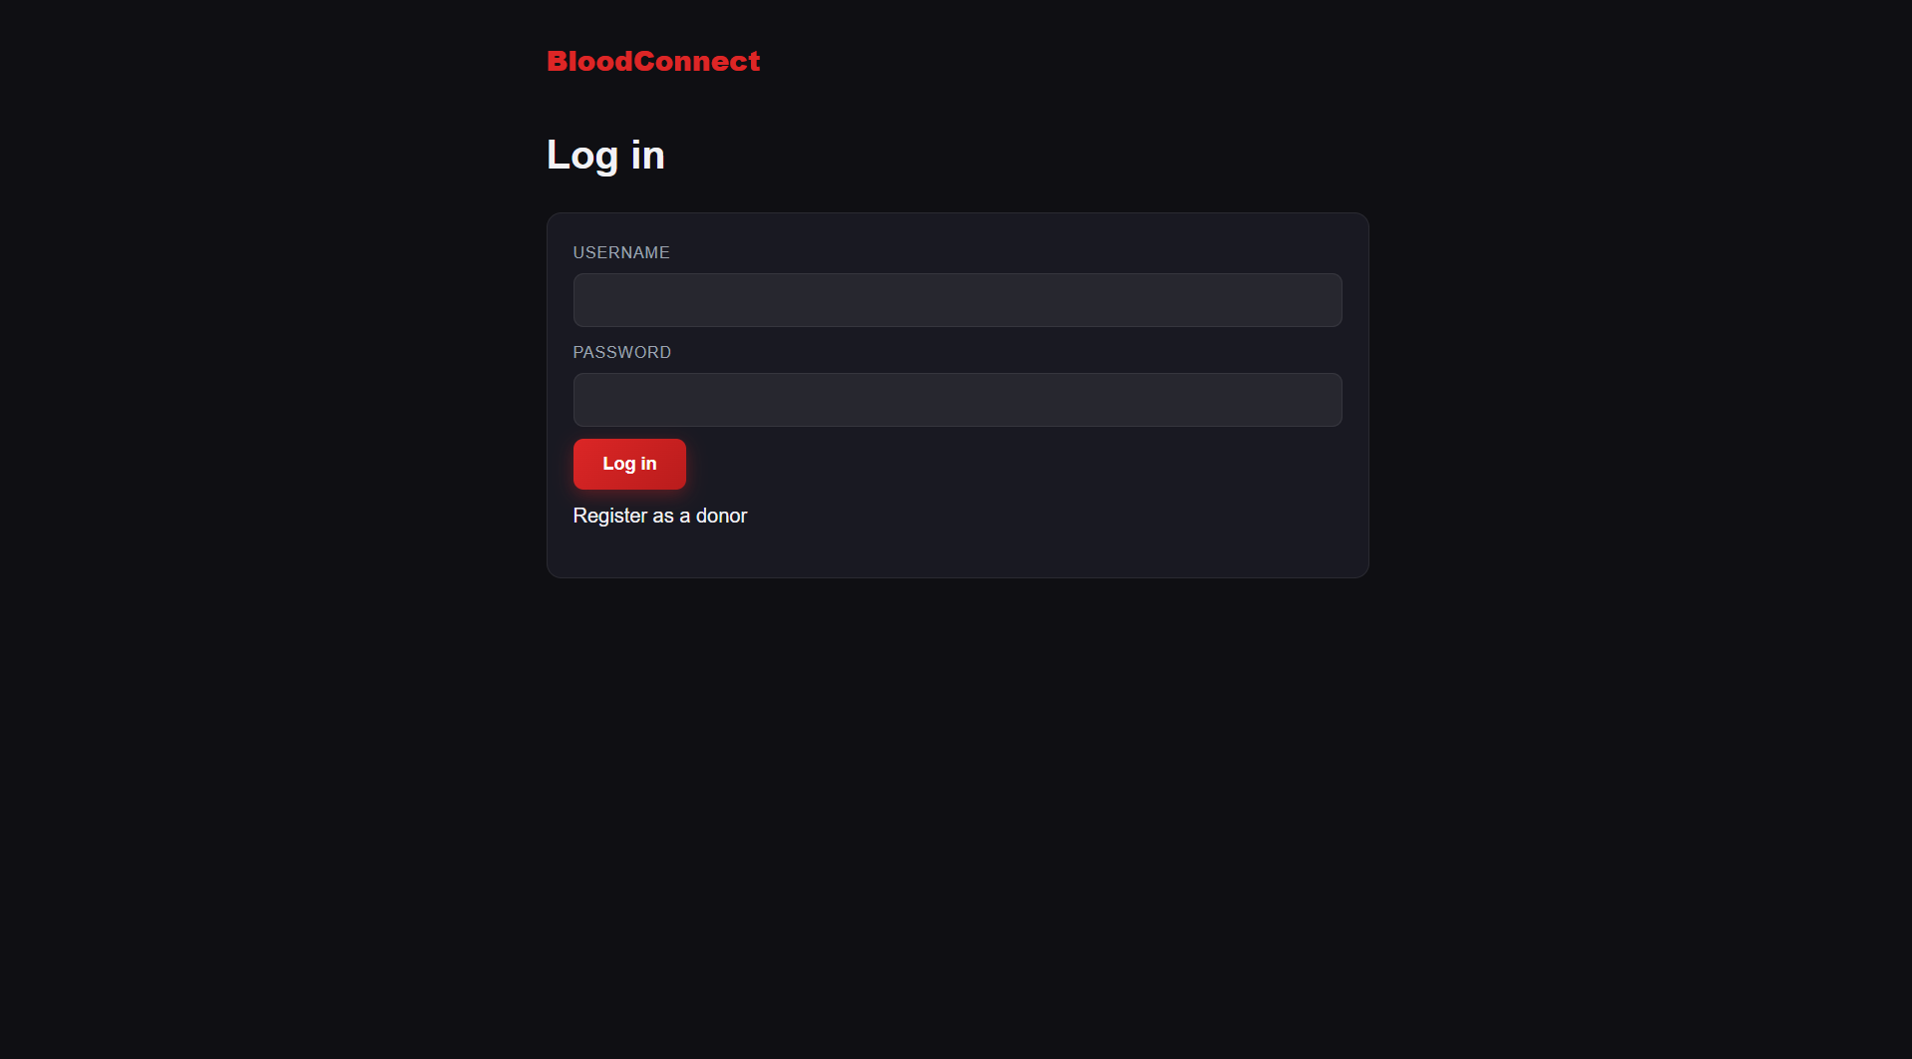
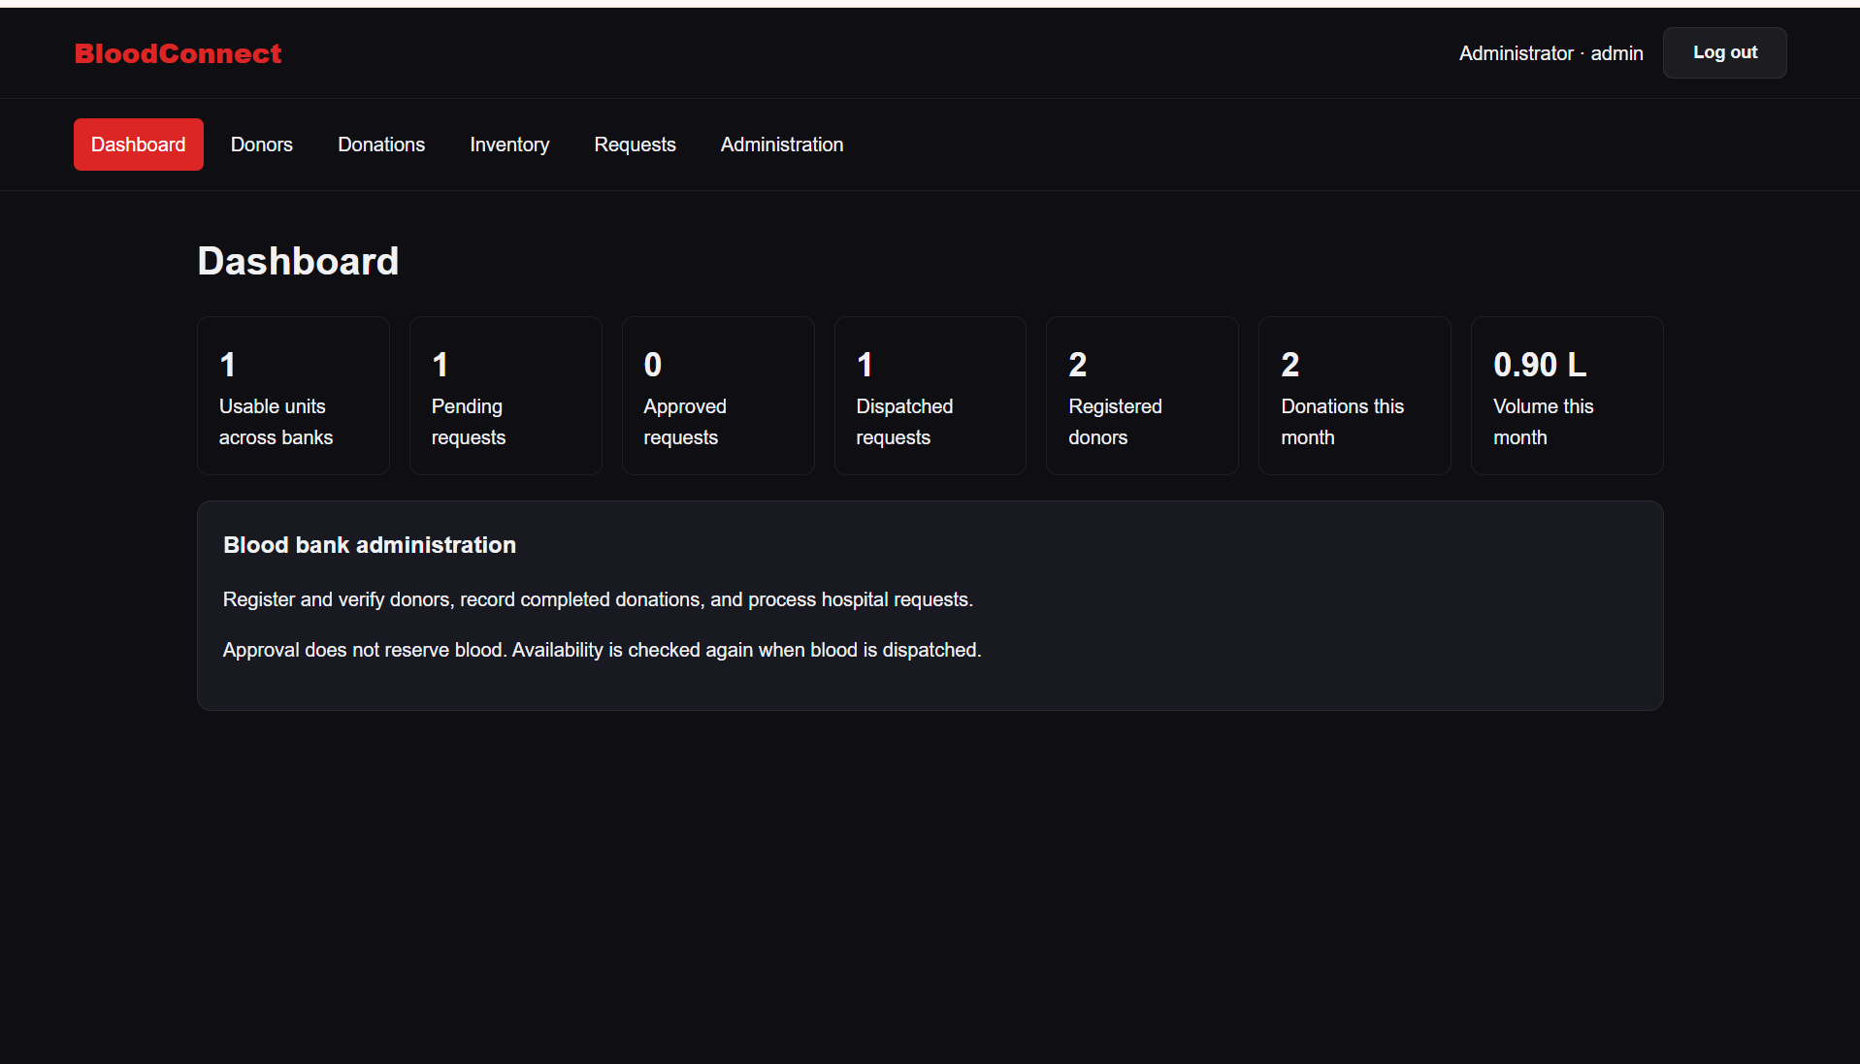
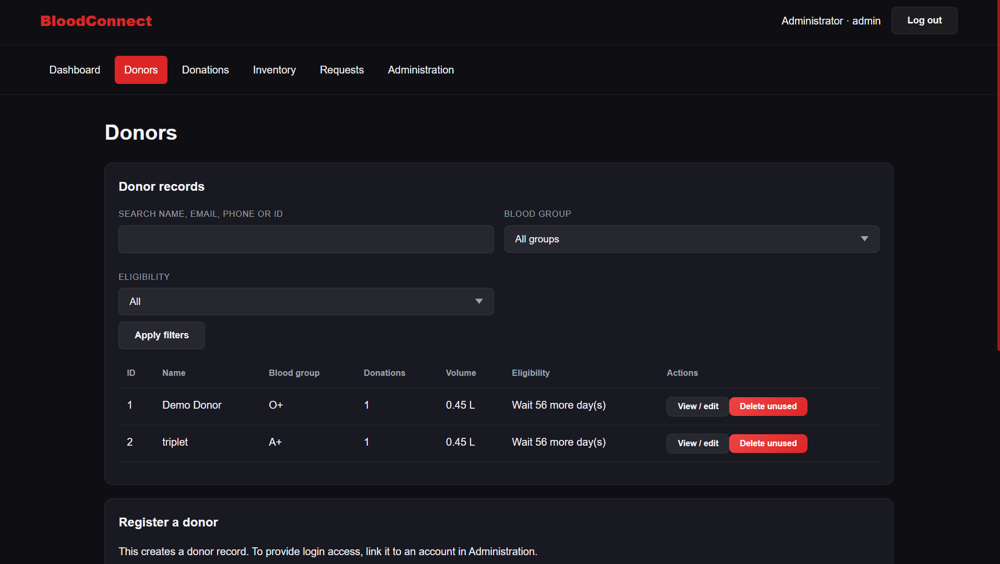
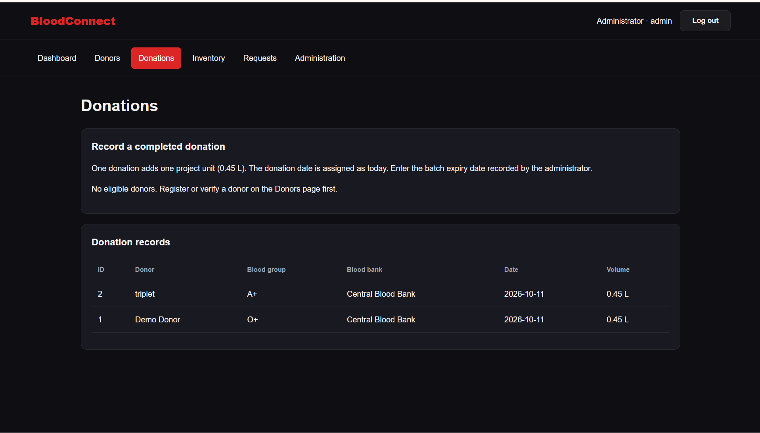
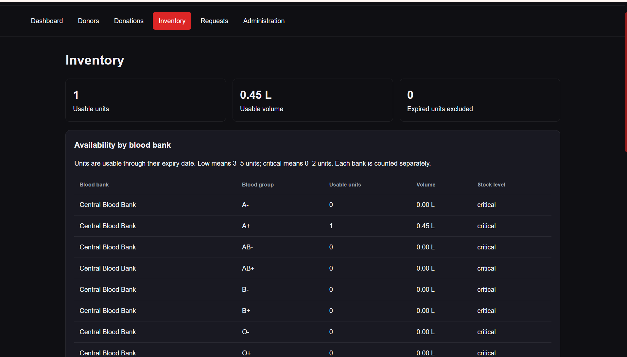
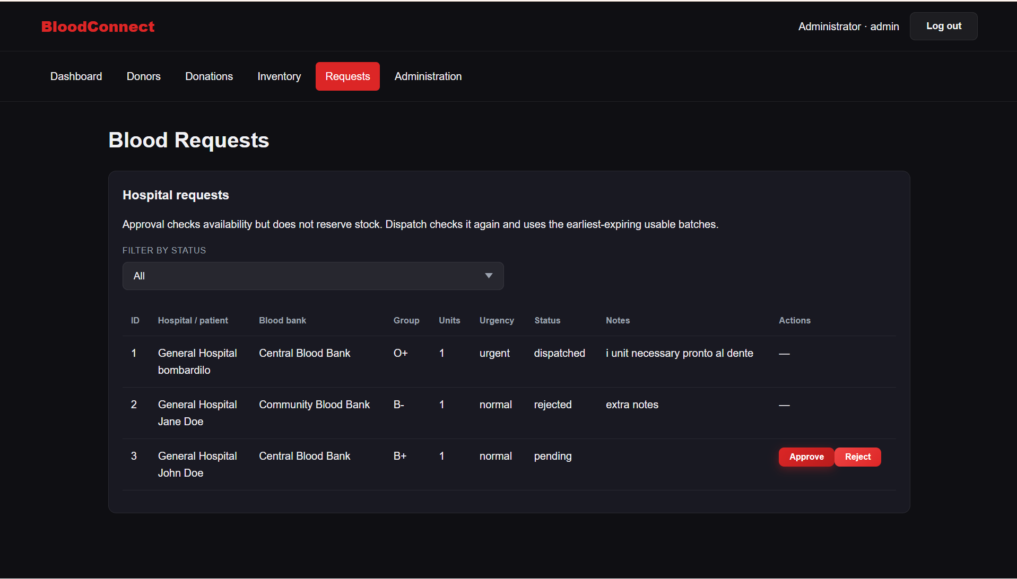
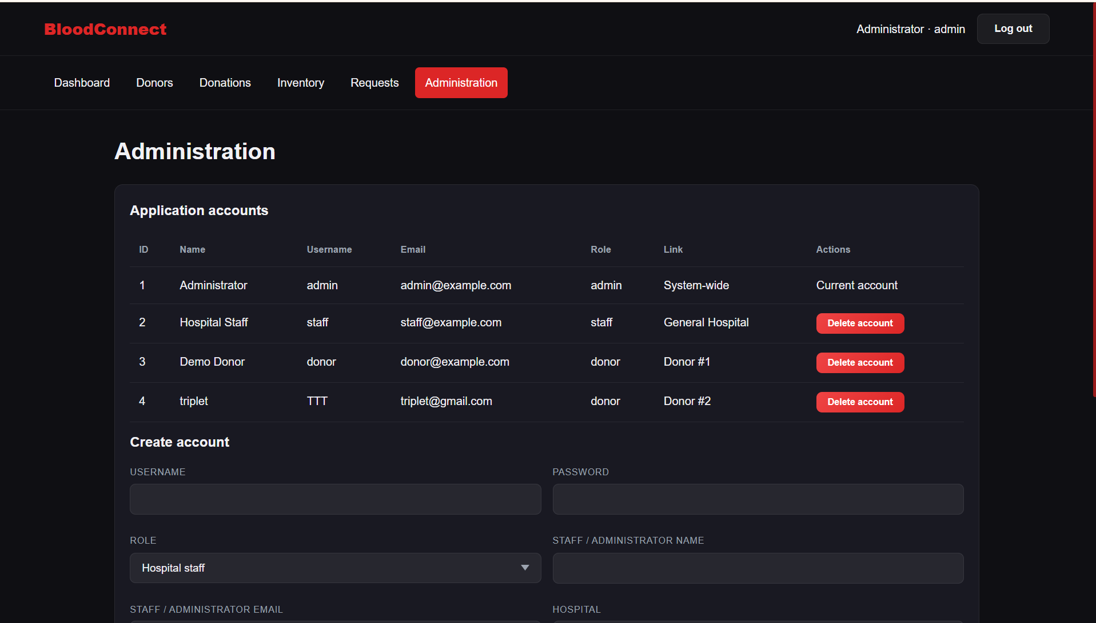
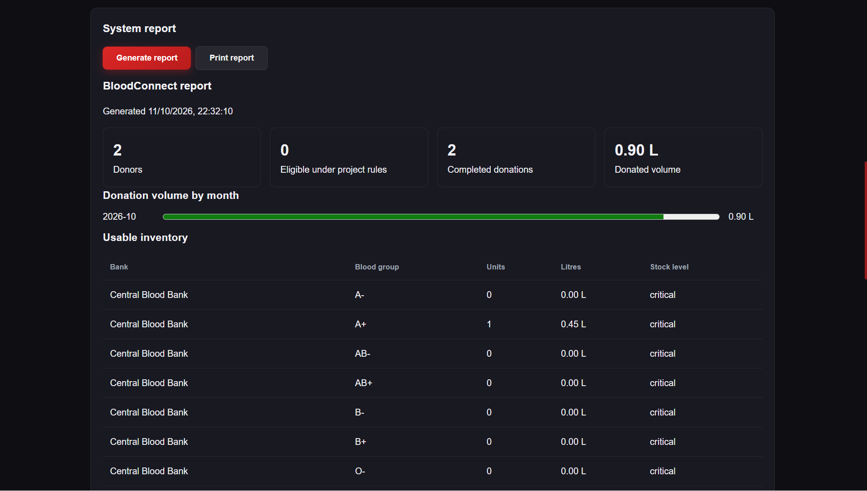

Hospital Staff Interface
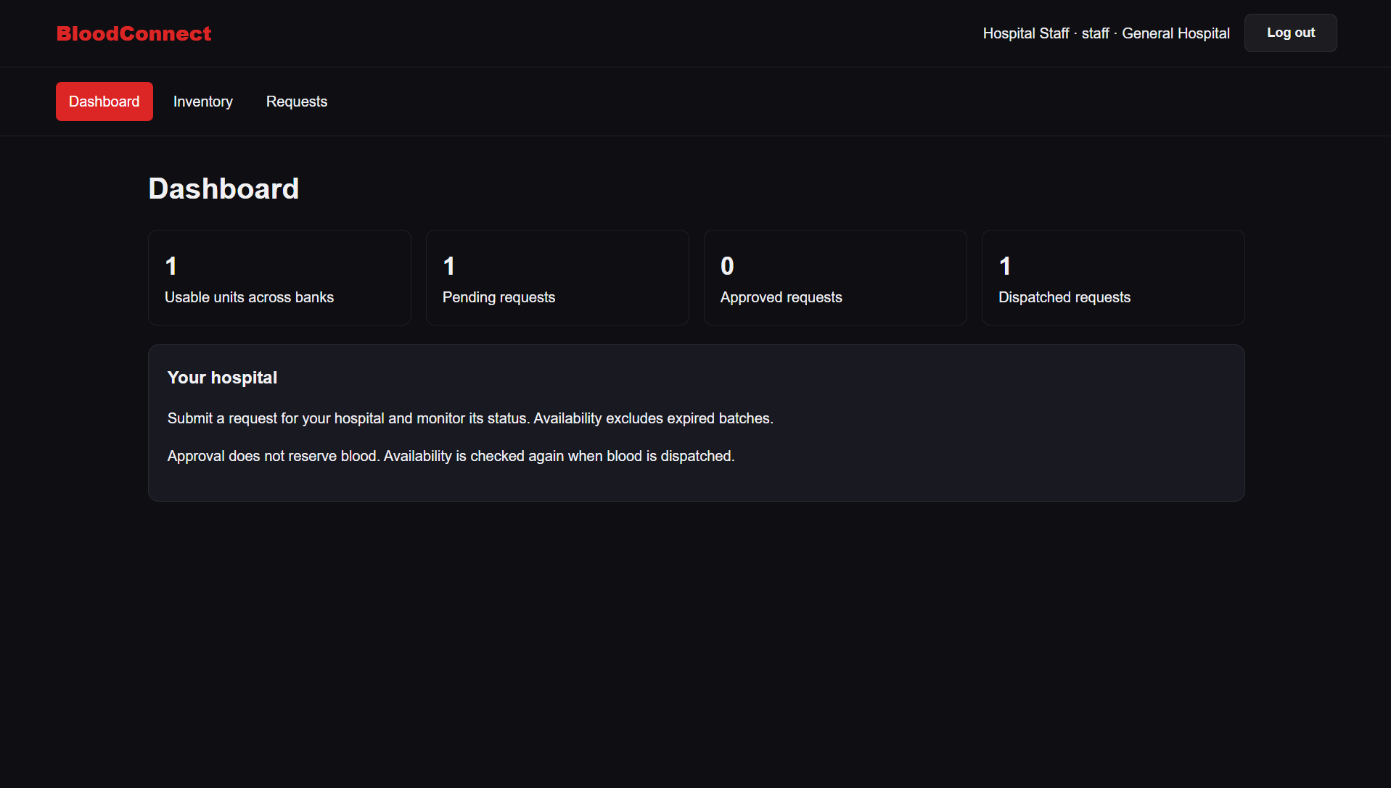
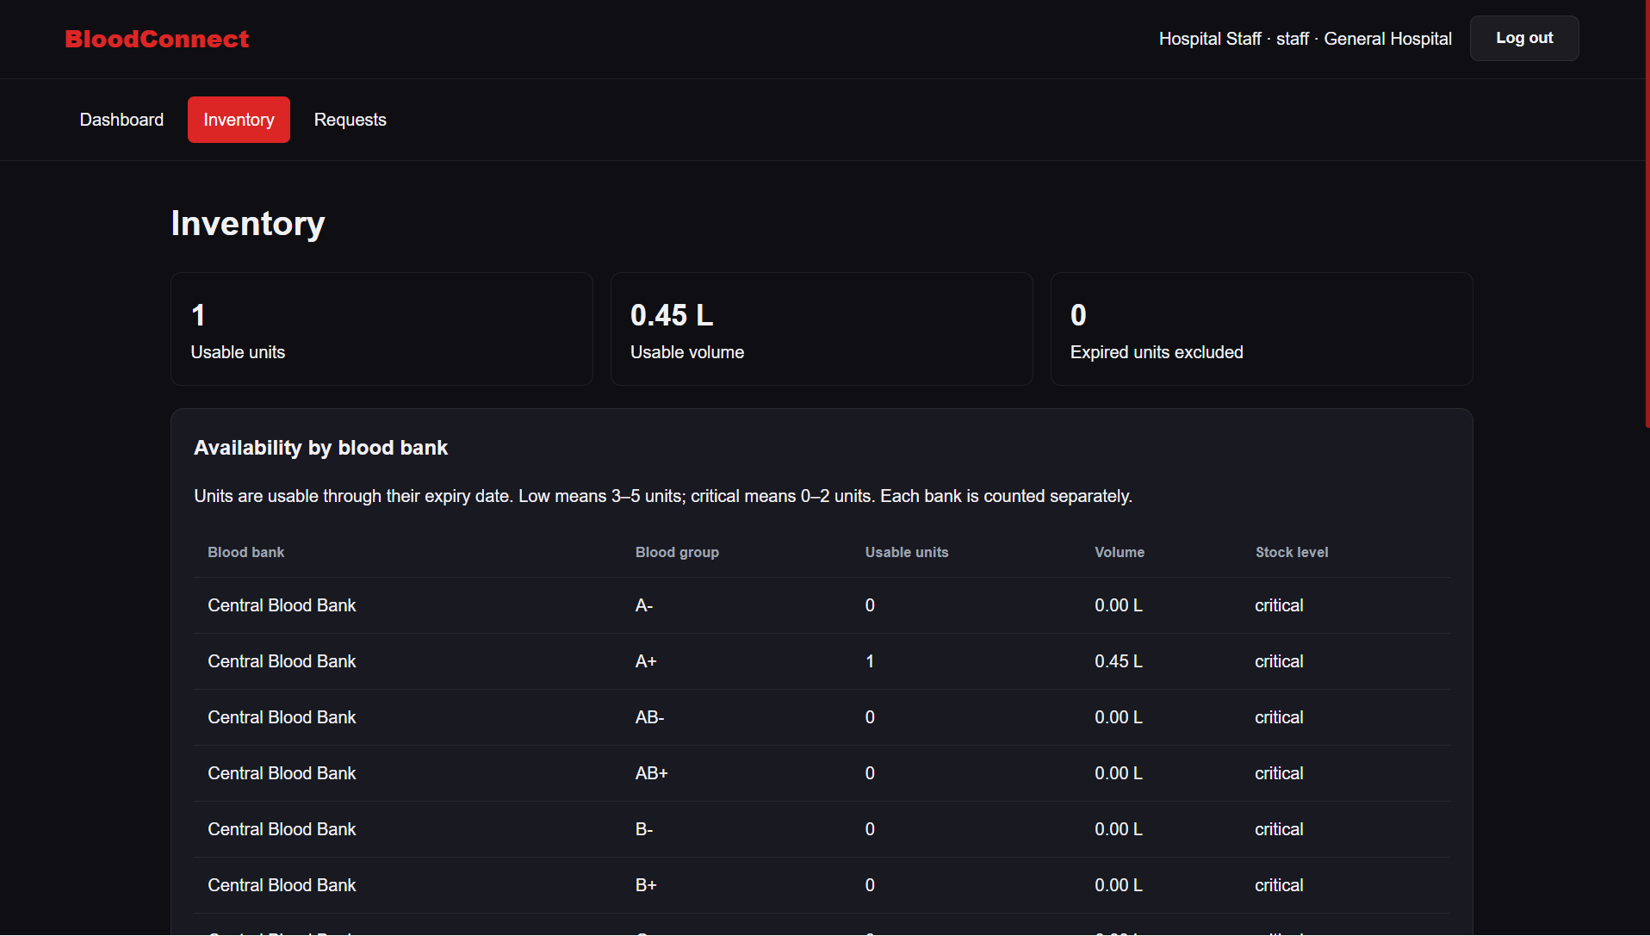
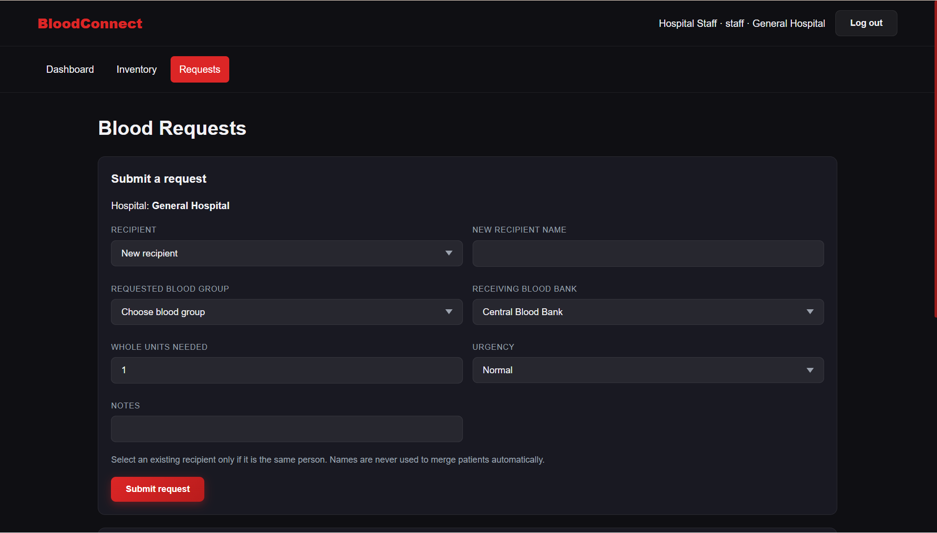

Donor Interface
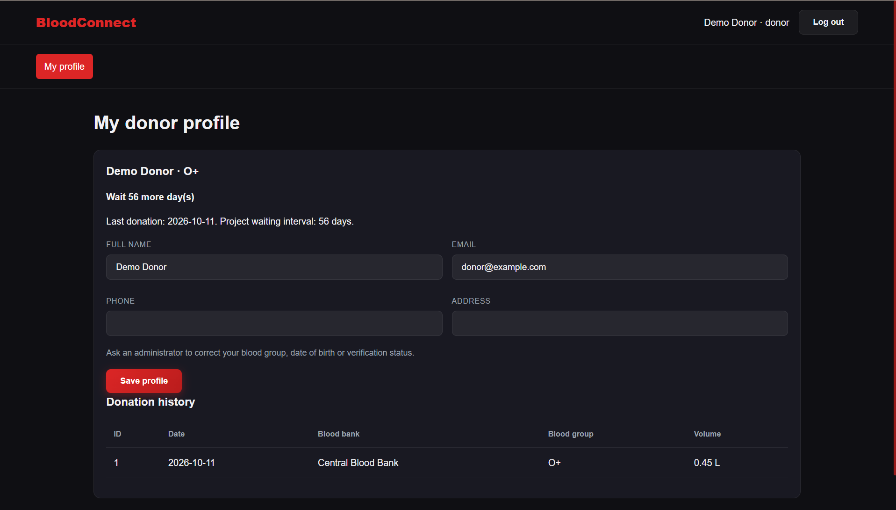

10. CHALLENGES FACED AND SOLUTIONS
Challenge | Solution
Database connectivity | Check PostgreSQL service status and verify the database environment variables.
Managing related records | Use primary keys and foreign keys to connect tables.
Retrieving related information | Use SQL JOIN queries to retrieve data from multiple tables.
Inventory updates | Validate quantity changes before updating stock.
Backend and database integration | Use the pg package to execute SQL queries from Express routes.
Invalid input | Validate required fields before executing database operations.

11. CONCLUSION AND FUTURE ENHANCEMENTS

11.1 Conclusion
BloodConnect provides a database-driven approach to managing blood donation information. The system stores donor, recipient, hospital, blood-bank, donation, inventory, request, and user records in a PostgreSQL database.
The use of relational tables, primary keys, foreign keys, SQL queries, and backend API routes helps organize the data and supports operations such as donor management, inventory updates, request tracking, and dashboard summaries. The project also demonstrates database design, relational mapping, and integration between a web application and a database.

11.2 Future Enhancements
- Add role-based access control for different users.
- Improve transaction handling for inventory and request updates.
- Add further database constraints for data validation.
- Improve blood-bank selection and inventory tracking.
- Add notifications for low stock and request updates.
- Improve reporting and dashboard features.
- Add automated testing and improve error handling.
- Improve security, backups, and deployment configuration.

REFERENCES
- BloodConnect Project Repository, connect branch. https://github.com/Sh4ggyd4wg/blood_bank/tree/connect
- PostgreSQL Documentation. https://www.postgresql.org/docs/
- node-postgres Documentation. https://node-postgres.com/
- Node.js Documentation. https://nodejs.org/docs/
- Express.js Documentation. https://expressjs.com/
- MDN Web Docs. https://developer.mozilla.org/
- Course material for 23CSE202 Database Management Systems, Amrita School of Computing, Amritapuri Campus.

